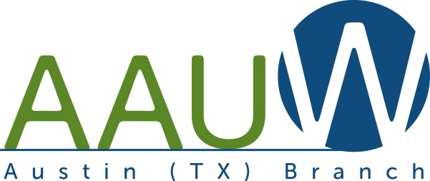

National College Conference for Women Student Leaders
NCCWSL 2021 – May 25th & 26th (Virtual)

Name: ____________________________________________________
The following documents MUST be completed and submitted by March 31, 2021:
- The AAUW Austin Scholarship Application and Personal Information Form
- A short essay of not more than 250 words written by you, explaining why you would like to attend NCCWSL and how you would use what you learned.
- Signed participation and post-event report statement:
I agree to fully participate in all sessions of the NCCWSL 2021 program and prepare a 3 to 5-minute YouTube video about what I learned and how I plan to put what I gained to work. That video will be ready to present at an AAUW Austin meeting in the Fall of 2021.
Signature: ___________________________________
AAUW Austin has funding for four (4) students from the greater Austin area to attend NCCWSL 2021, which will be a virtual event running from 11 a.m. to 5 p.m. on Tuesday and Wednesday, May 25 and 26, 2021. For further details, see NCCWSL 2021.
Scholarship applicants must be enrolled in any accredited post-secondary education program and be able to attend all sessions on both days of NCCWSL 2021.
If questions, please call or text Roberta Coffin at (714) 679-8697 or via email – rwc@scriptacommunicates.com.

AAUW Austin (TX) Scholarship for NCCWSL 2021
Application and Personal Information Form
Name: _________________________________________
Home Address: _________________________________. Apartment/Unit # _________
City: _______________________, State: ________________-Zip: _____________
Phone: _____________________________________________
Email address: _______________________________________
Degree Plan: ________________________________________
Future Career Goal: ___________________________________
Number of completed college credits: ___________________
List college-related extracurricular activities/leadership roles/special interests:

If employed, where to you currently work? _______________________
Sign statement and submit both pages of this form
and your essay by March 31, 2021 to:
AAUW-ATXmembership@aauw.net

